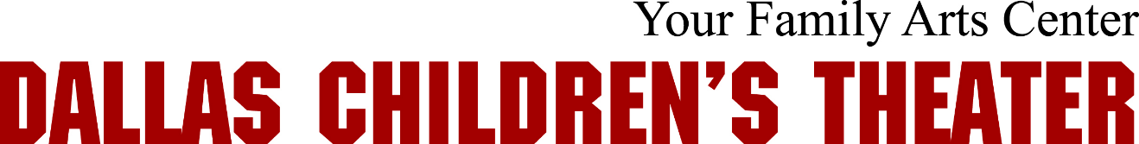

JOB DESCRIPTION

Title: General Maintenance Technician
Reports to: Facilities Manager
Status: Non-Exempt Hourly
Compensation: $16.00/hour; if full-time...benefits valued at over $7,000 that include: Health insurance, dental insurance, group life insurance and AD&D, LT Disability; plus PTO
Start Date: Anticipated start date March 20 or sooner

Position Overview

Dallas Children's Theater (DCT) is seeking a motivated and responsible professional to join our team to assist with facility operations. Key responsibilities include: ensuring a safe and hazard free workplace environment; respond to minor disturbances and emergency calls; inspect property for hazards and equipment in need of repair; and assist in supervising contracted services that support daily operations. Qualified candidates will have a minimum two years of experience or equivalent education and knowledge and experience in facility maintenance. For the right qualified person this position is a full-time position, eligible for overtime after 40 weekly hours. Flexible schedule and the ability to work nights and weekends is desirable. A part-time role is an option. DCT is an Equal Opportunity Employer.

Key Responsibilities
- Organization skills to help with maintaining a clean and safe work environment.
- Building repairs and maintenance on flooring, drywall, theatre seating, office furniture.
- Address leaks, clogs or other plumbing problems; address basic problems with the building’s electricity.
- Assist Facilities Manager in supervising contracted maintenance and repair services that support day-to-day operations, such as cleaning, roofing, landscaping and HVAC services.
- Regularly tour the Facility to look for and identify building concerns, review logs, identify opportunities and ensure there are no building operational abnormalities or inefficiencies.
- Respond to minor disturbances and emergency calls; serve as a responder in times of emergency.
- Security duties such as addressing homeless and loitering.
- Other duties as assigned.

Required Qualifications:
- Minimum of 2-5 years related experience.
- Physical stamina to work in either inside or outside environments, operate equipment and, handle a full shift of being active and on your feet.
- Attention to detail to ensure that all jobs are completed in an exemplary manner and any potential hazards or warning signs of problems are not overlooked.
- Ability to deal with contractors and fellow employees in a courteous and tactful manner.
- Excellent verbal and written communication skills and a demonstrated commitment to safety, teamwork and co-operation.
- Demonstrated experience with hand tools such as wrenches, hammer, screwdrivers, trowel, chisels, files and measuring instruments.
- Demonstrated mechanical aptitude including proficiency in the use of tools and equipment associated with most building repairs and maintenance activities.
- Demonstrated carpentry ability to handle basic repairs around the building utilizing power tools.
- Must have excellent problem solving skills and be adept at troubleshooting maintenance problems.
- Must have basic knowledge of major building systems (HVAC, mechanical, plumbing, electrical, lighting control, fire alarm, fire protection, security).
- Maintain a regular and reliable level of attendance and punctuality with an open availability for shifts.
- Able to multi-task and perform miscellaneous job related duties as assigned.

Beneficial Qualifications
- Knowledge of Theater carpentry to assist in production
- Experience with any or all of - Sky Jack, Scissor Lift, Fork Lift, Boom Lift and Fall Arrest is an asset
- Ability to work from verbal and written instructions; accurately interpret sketches, diagrams, and building drawings.
- Able to diagnose minor heating/cooling issues

